The objective is to run three map redunce programs

For wordmean

Wordmedian

Wordstandarddeviation

**WordMean**

First step is to run the Hadoop services using start-all.sh

Next step is to create a a file , now this can be done via nano edotor or copied from Local or Hdfs to the desired location

The location of the map reduce jar file is already provided

To run the mapreduce program use the following command

Hadoop jar <jar location> <input file > <output file>

Since in our case there are multiple programs in jar file we have to specify which program to run before the input file

Hadoop jar <jar location> wordmean <input file > <output file>

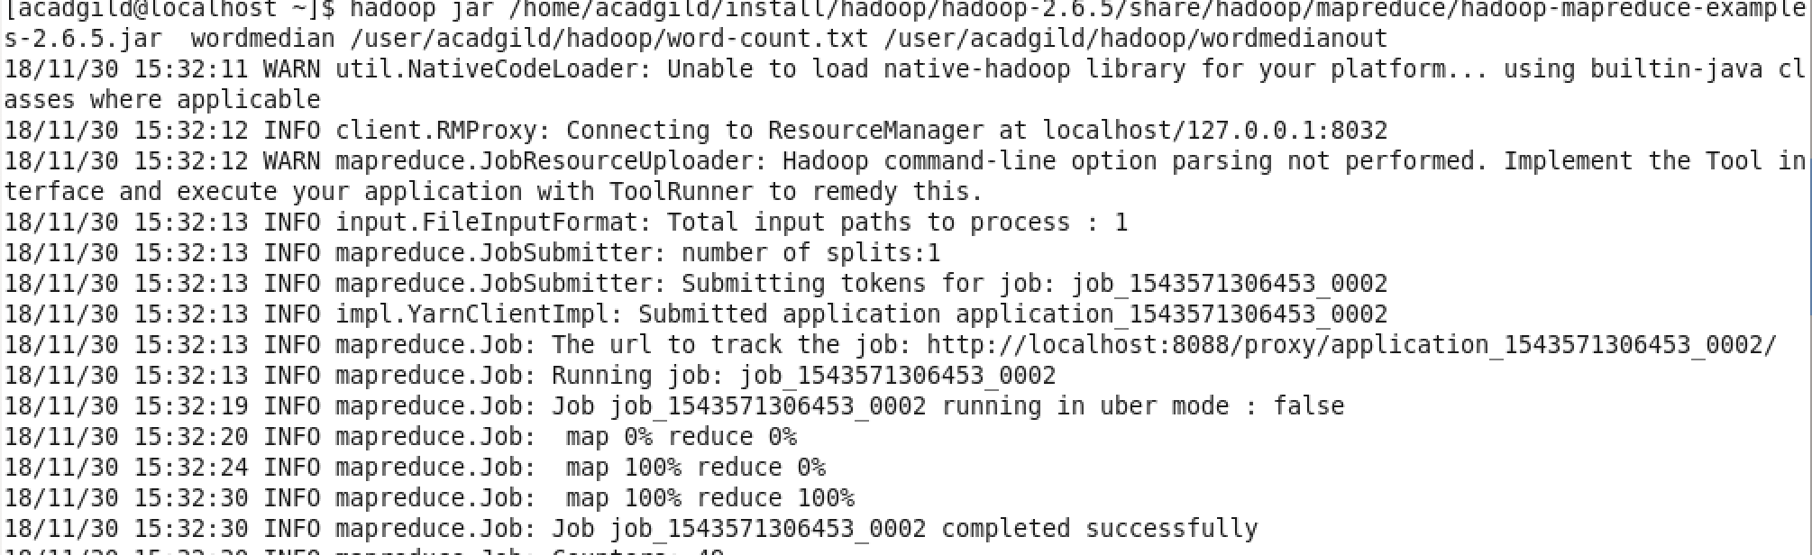

To view the out put file go the given out put location and view using cat command

Hadoop fs -cat <output location>

The out put file will be in part-r-0000

**Wordmedian**

Command remains same , we need to change the program to run

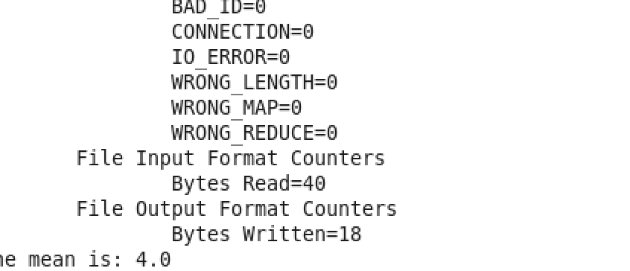

Hadoop jar <jar location> wordmedian <input file > <output file>

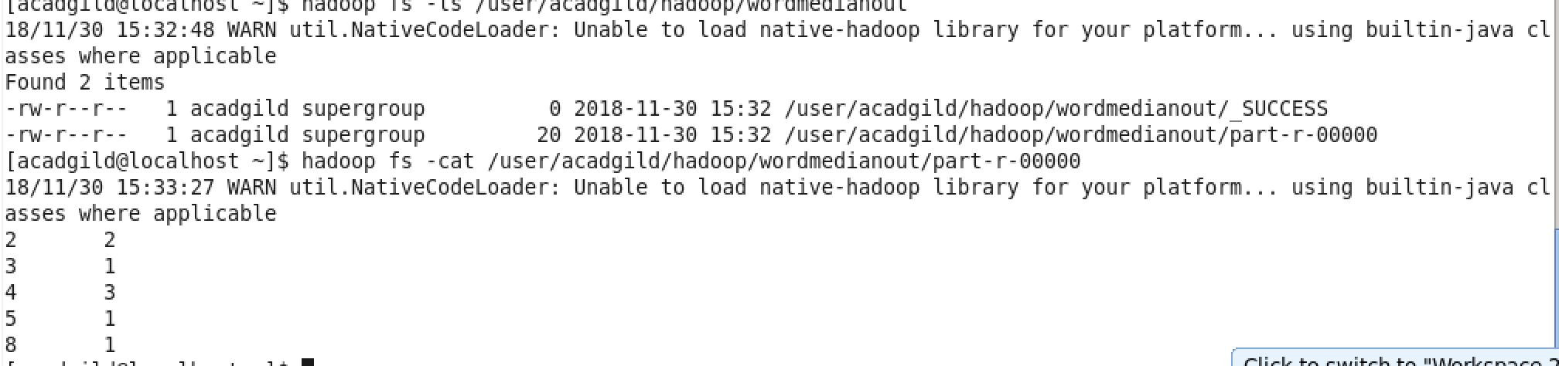

**Word Standard Deviation**

Hadoop jar <jar location> wordstandarddeviation <input file > <output file>

At the end of program you will receive the output

